Docker commands can be executed in command prompt

Container is the running environment for an image

Container contains

* Application image : postgres , redis , mongo , etc
* Container has a port binded to it which allows it to talk to the application running inside it
* Container has a virtual file system

***Download a docker image***

docker pull {{image_name}}

example – docker pull redis

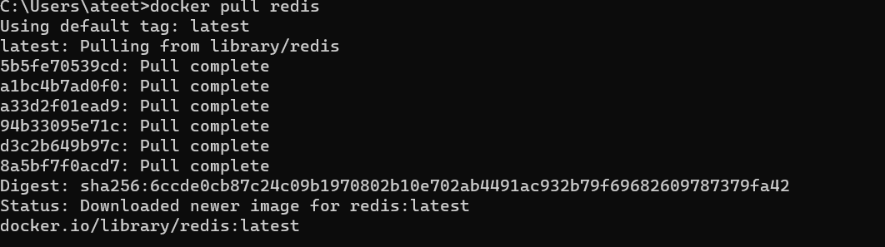

***Check for list of docker images***

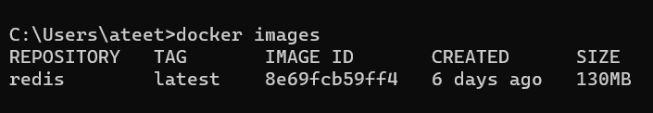 docker images

The tag shows the version of the image downloaded

***To start running an image***

docker run {{image_name}}

example – docker run redis

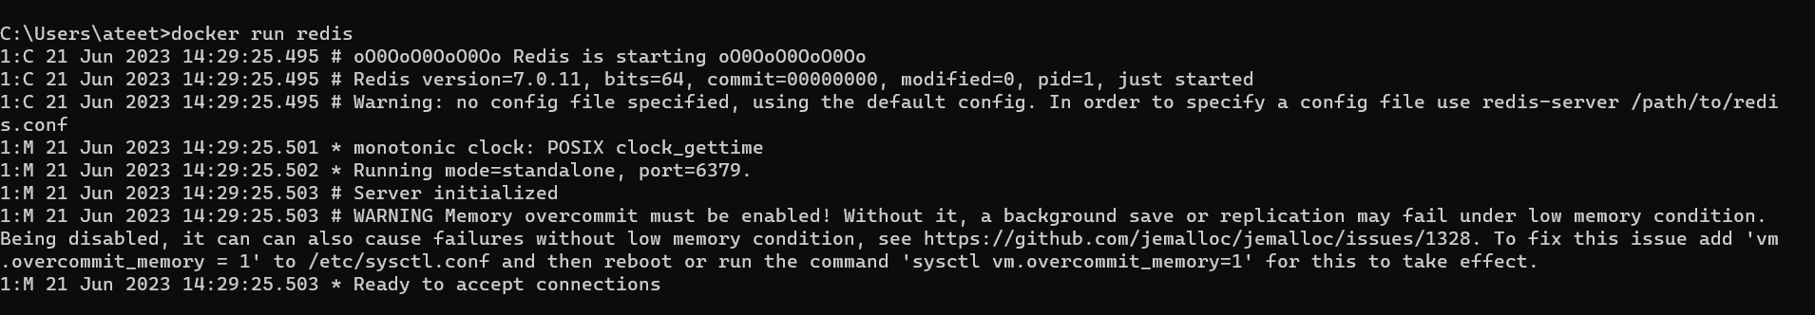

Once an image is running the environment in which the image is running is called a container

To see list of the containers that are running currently

 docker ps

***Stop a running image / container***

Just ctrl + C on the keyboard

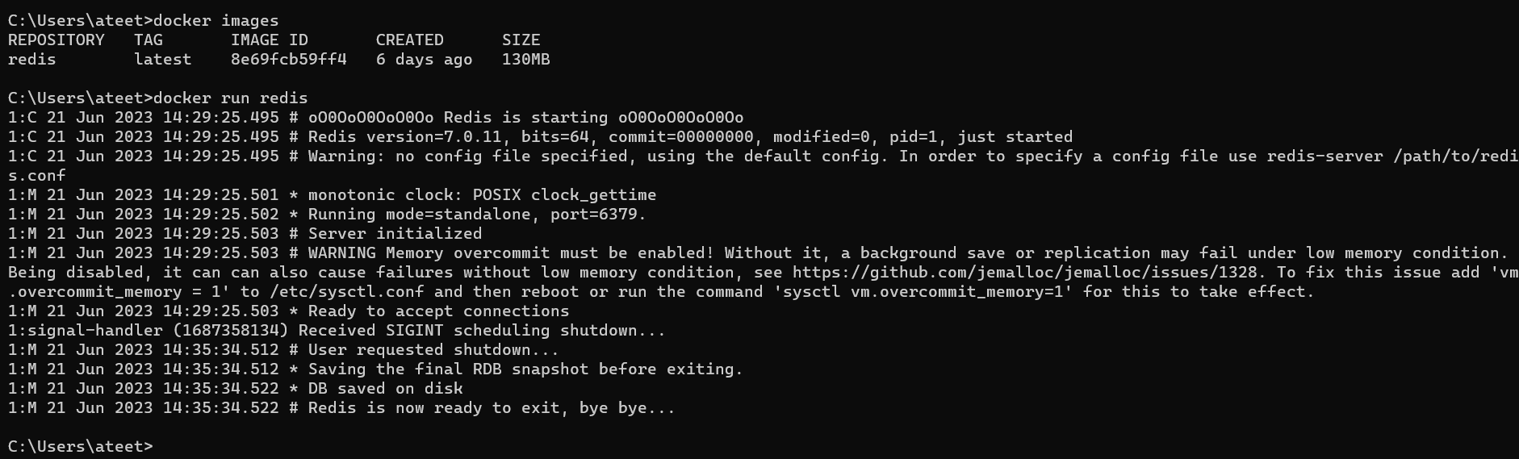

Observe the change in timestamp in the screenshot which means the container/image was stopped running from the keyboard by ctrl + C

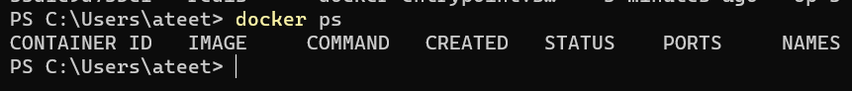

No more running controllers after the running redis container was stopped

***Run a container in detached mode***

docker run -d {{image_name}}

example – docker run -d redis

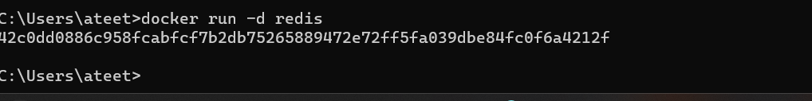

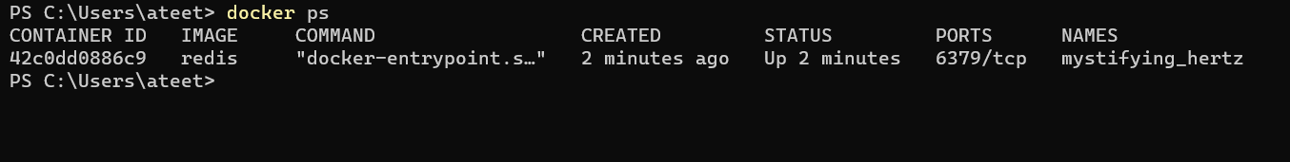

***To stop a container***

docker stop {{id of container}}

example - docker stop 42c0dd0886c9

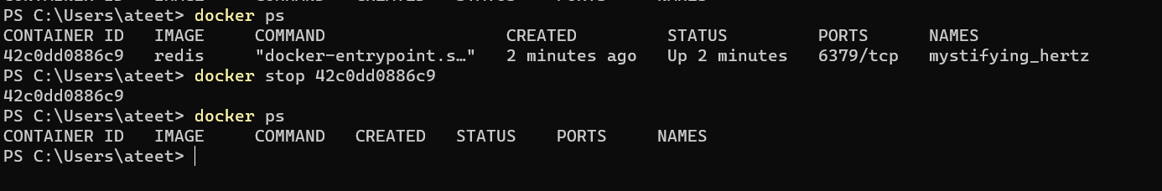

***To start a stopped container***

docker start {{id of container}}

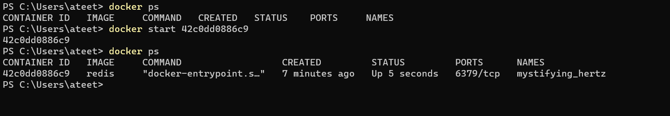example - docker start 42c0dd0886c9

***To check list of containers that are currently running as well as stopped*** (like history of containers that were started or are running)

docker ps -a

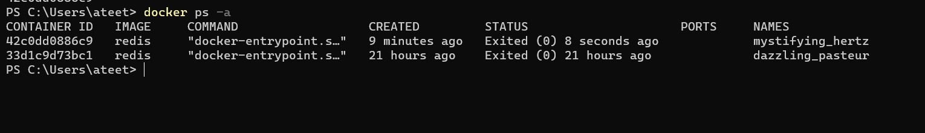

***To download an image of a specific version and run it parallely***

docker run {{image name}}:{{version number}}

example – docker run redis:4.0

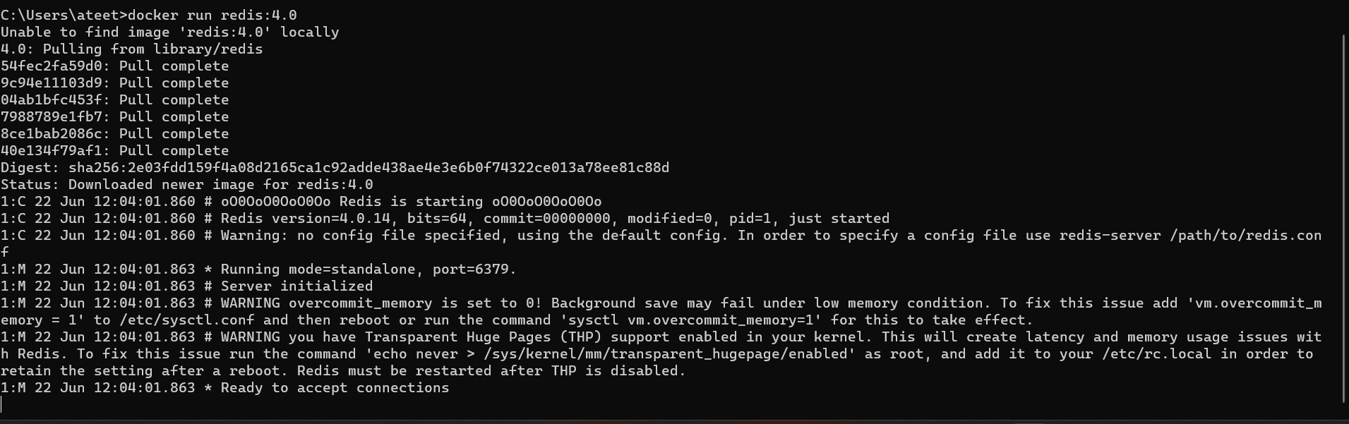

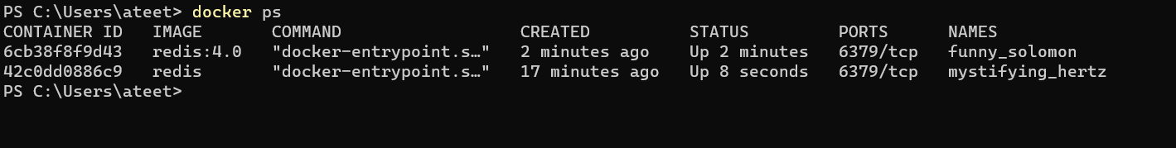

Notice 2 redis images of different versions are running

***Run a docker container from a different host port***

Example from host port 6000 to container port 6379

Example : docker run -p6000:6379 redis

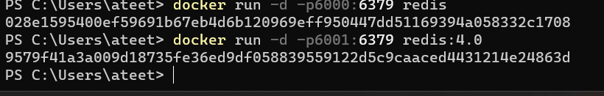

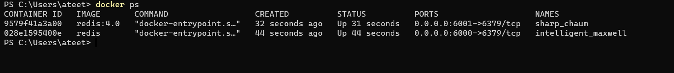

***Name a container with a specific name instead of random***

docker run --name {{name of container}} {{image}}

example : docker run -d -p6000:6379 --name redis-older redis:4.0

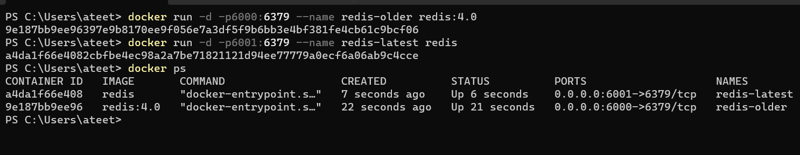

***Find logs related to a particular container***

docker logs {{container name}}

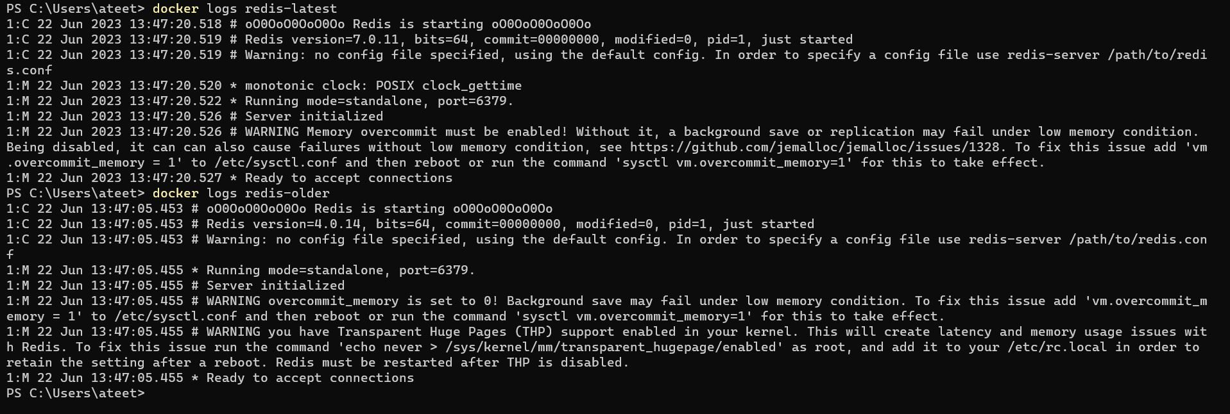 example – docker logs redis-latest

***Run a command in a running container and get bit of information such as environment of the container***

docker exec -it {{container id or container name}} /bin/bash

example - docker exec -it a4da1f66e408 /bin/bash

